SR UNIVERSITY

AI ASSIST CODING

*Lab:1 Environment Setup – GitHub Copilot and VS Code Integration*

ROLL NO:2503A51L10

NAME:K.Praneeth

BATCH:19

**TASK#1:**

**Prompt used:**

Write a comment:# Function to check if a string is valid palindrome (ignoring spaces and case) and allow Copilot to complete it.

**Code Generated:**

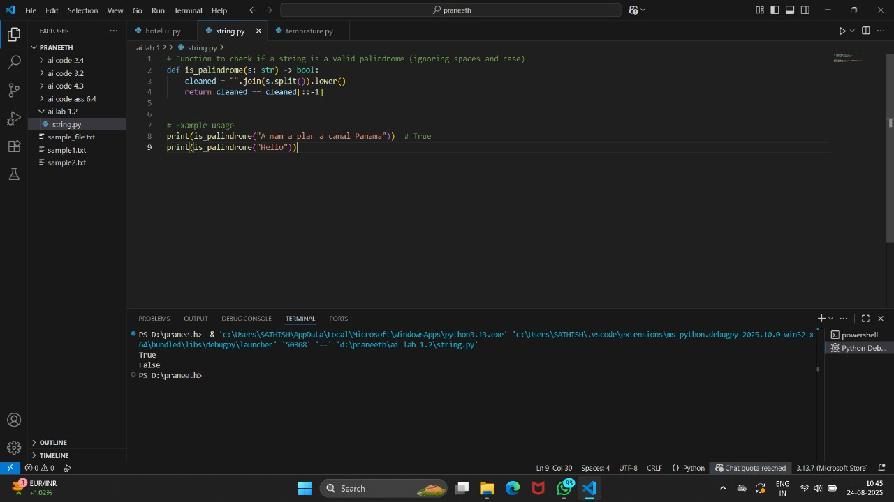

**Output After executing Code:**



**Observations:**

* Used of the palindrome to verify the given is string or not
* In this used the code if any given word contains the spaces and special symbols it if defined as the not as string

**TASK#2:**

**Prompt used:**

Generate a python function that returns the Fibonacci sequence up to n terms Prompt with only a function header and docstring

**Code generated:** 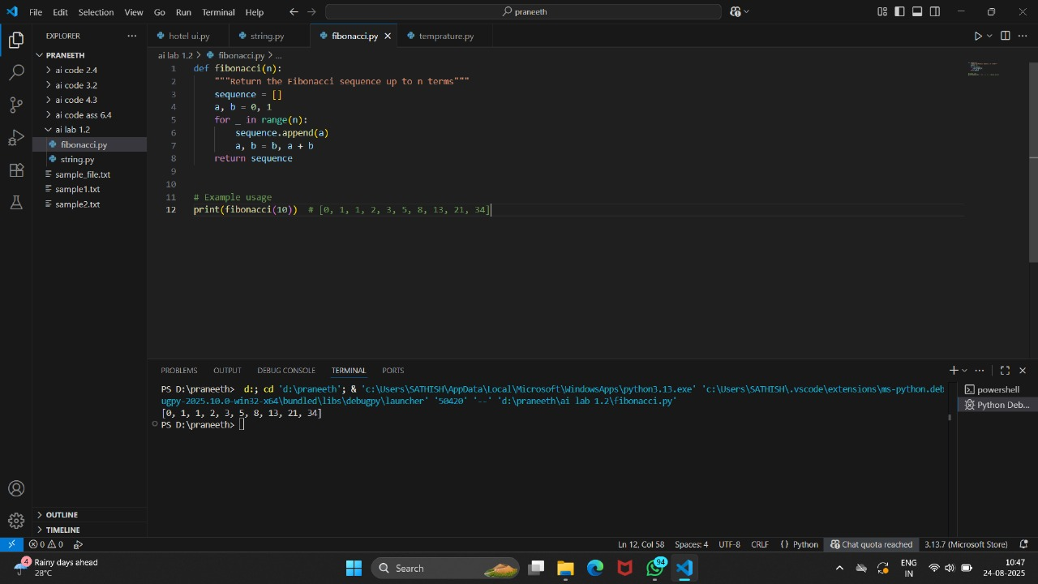

**Output after executing Code:**



**Observations:**

* By following as the maths formula the given numbers it finded the Fibonacci sequence for the given numbers
* Using the conditions in python

**TASK#3:**

**Prompt used:**Write a comment like #Function to res=verse a string and use copilot to generate the fumction

**Code generated:**

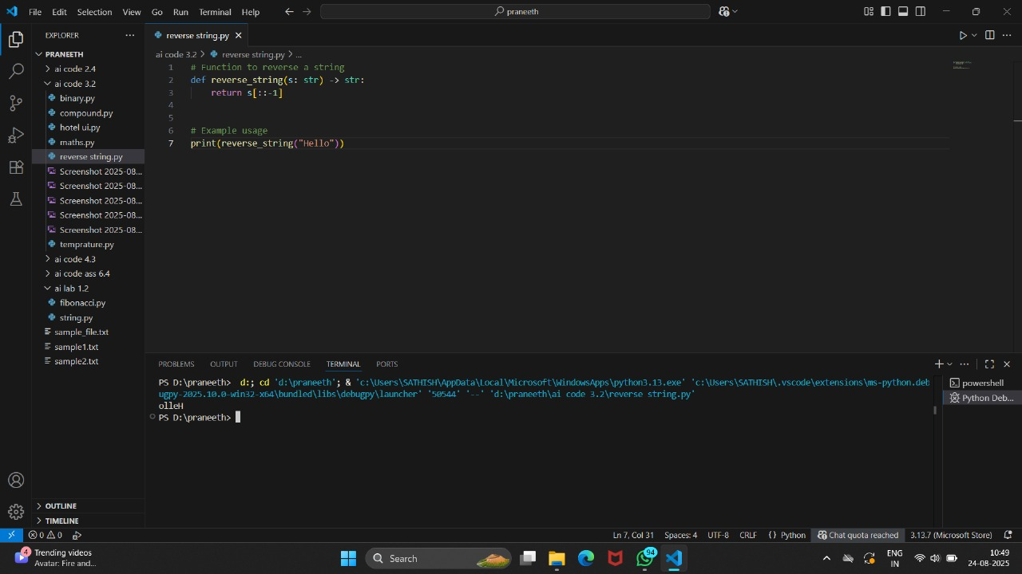

**Output after executing Code:**



**Observations:**

* Using the string functions in the python reversed the given string “hello” as the using reverse as “olleh”
* This is done in the fraction of seconds by the python interpritter

**TASK#4:**

**Prompt used:**

Generate a program that simulates a basic calculator (add,substarct,multiply,divide). Write the comment:Simple calculator with 4 operations and let AI complete it.

**Code generated:**

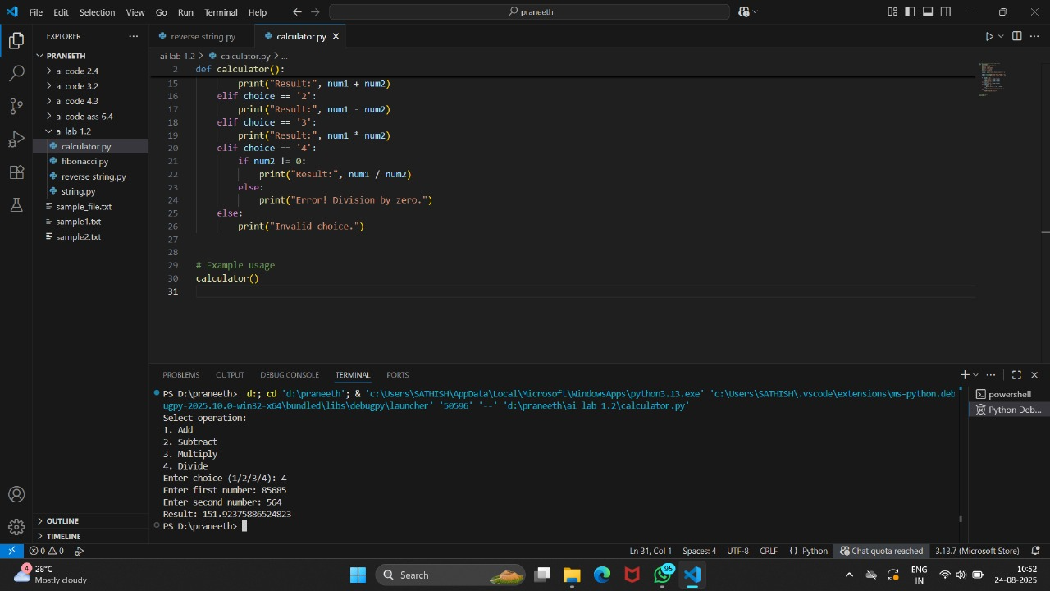

**Output after executing Code:**



**Observations:**

* In the above code for the calculator its done the operations addition ,substraction,multiplication and division for the given numbers by choosing the choice which we want to do as numbers 1,2,3,4

**TASK#5:**

**Prompt used:**

Use a comment to instruct AI to write a function that read a file and returns the number of lines

**Code generated:**

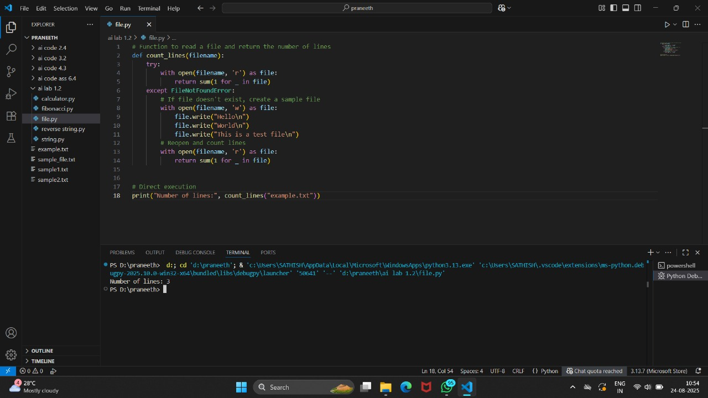

**Output after executing Code:**



**Observations**:

* The given code open the file by the given access path in my pc and it read the whole file and counted the number of lines the in the text file.
* After the number given as the output.